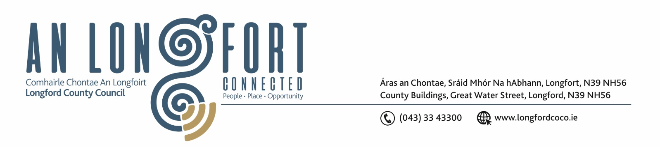

5u Iuil 2017

Chuig: Gach Ball don Chomhairle.

A Chomhairleoir,

Iarrtar ort bheith i láthair ag Cruinniú Míosuil Chomhairle Chontae Longfoirt a tionólfar i Seomra na Comhairle, Aras an Chontae, Longfoirt ar an Chéadaoin, 12u Iuil 2017ag 4.00 p.m chun gnó a dhéanamh d’réir an Chláir thíos.

You are requested to attend the Monthly Meeting of Longford County Council to be held in the Council Chamber, Aras an Chontae, Great Water Street, Longford, on Wednesday, 12th July 2017 at 4.00 p.m. to transact business, as set out on the Agenda hereunder.


Mise le meas,

_______________
Anne Lee,
Meetings Administrator.

C L A R

Prayer before Meeting.

- Confirmation of Minutes of Monthly Meeting of Longford County Council held on the
14th June 2017 – copy enclosed.

2. Matters arising from Minutes.

3. To note Chief Executive Orders. (Summary herewith)

4. To note Monthly Management Report - to follow.

5. To note adopted Minutes of Corporate Policy Group Meeting held on
10th May 2017 - (copy enclosed).

6. Economic and Community Development, Planning, Human Resources & Corporate Services, Cultural & Recreational Services.

- To note Planning Applications received since June meeting of the Council.

- Update on Longford Economic Forum to Update on Strategic Economic Projects.

- Proposed Variation No. 3 of the Longford County Development Plan 2015-2021 –
Consideration of Proposed Variation and the Report of the Chief Executive - copy enclosed.

- Consideration of Report in accordance with Section 179 of the Planning and Development Act 2000 (as amended) and Part 8 of the Planning & Development Regulations 2001 (as amended) in respect of the construction of a footbridge over the Inny River at Clooneen & Newcastle, Ballymahon, Co. Longford- report to follow.

- Notices of Motions, submitted by Councillors, as listed hereunder -

Councillor Mark Casey.

“I propose that an update be given on the progress to date on updating the County Development Plan with the new setback distances of ten times the tip height of turbines from residential properties and other centers of human habitation. And that this issue be kept on the agenda of every monthly meeting until the County Development Plan is updated."

“That this Council supports the development of the proposed Food Hub in Lanesborough,
which, when it is up and running, will create upwards of 50 jobs in the local area.”

Councillor Michael Carrigy.
“I call on the IDA to find an immediate replacement business for the site which has been occupied by Cameron Willis to provide much needed jobs for Longford. “

Councillor Peggy Nolan
“That this Council puts in place a plan to utilise the natural amenity that is the River Camlin stretching from Granard to Clondra. The plan to have at its core an economic dividend from activities on the river to walk and cycleways, to the heart of the county. As it is the sole responsibility of Longford County Council, with an annual spend of up to and over €20,000, we could seek funding for a Business Plan.”
7. Finance & Information Systems.

(a) To note Public Liability Claims received during June 2017 – report enclosed.

8. Housing, Infrastructure, Environment & Emergency Services.

(a) To note adopted minutes of the Infrastructural and Environmental Services Strategic Policy
Committee Meeting held on the 13th April 2017 - enclosed.

(b) Consideration of disposal of Freehold Interest of No. 45 St. Michael’s Road, Longford to John Mimnagh in accordance with the terms of Section 183 of the Local Government Act 2001 issued on the 19th May 2017.

(c) Consideration of the following recommendation from Infrastructural and Environment Strategic Policy Committee -

“That Longford County Council take in charge roads where work has been carried out by a community and the road surface is in very good condition and where all the works have been carried out to a standard acceptable to Longford County Council.

9. General

- Notices of Motions submitted by Councillors, as listed hereunder –

Councillor Mark Casey.

“That this Council writes to the Minster for Health seeking free car parking in hospitals for cancer patients who are required to attend frequent hospital appointments for treatment. The cost of tolls and parking is €22 per day this is leaving out the cost of fuel, food and time off work. Overall the cost of cancer is immense and ICS have made a conservative estimate that it costs €862 per month, rising to €1,200 in some cases. This is discounting the €1,400 a month drop in income faced by three in five cancer patients. I do acknowledge that this is an important source of income for hospitals however it is unfair to put this burden on already hard-pressed cancer patients who must use hospital parking services on a regular basis.”

Councillor Michael Carrigy.

“I call on the Minister for Children to address the issue in the CCSP scheme which has brought additional administration for childcare providers. The providers must be supported to make the scheme sustainable.”
“I call on the M50 Operators, Gardai, Speed Camera Operators and the Insurance Companies to work together to identify vehicles which are on our roads and not insured. A reduced number of these vehicles would reduce insurance premiums for all car owners.”

- Correspondence – circulated.

- Letter dated 21st June 2017 received from the Department of Social Protection in relation to FOI request regarding information pertaining to the proposals of the Citizens Information Board to merge 51 Local Independent MABS Boards and
42 CIS Structures into 8 Regional Boards.

10. Votes of sympathy.

11. Training -

Consideration of Report from Corporate Policy Group.



